* Fork

一：打开总仓库 <https://github.com/twoutlook/misdj-case001.git>

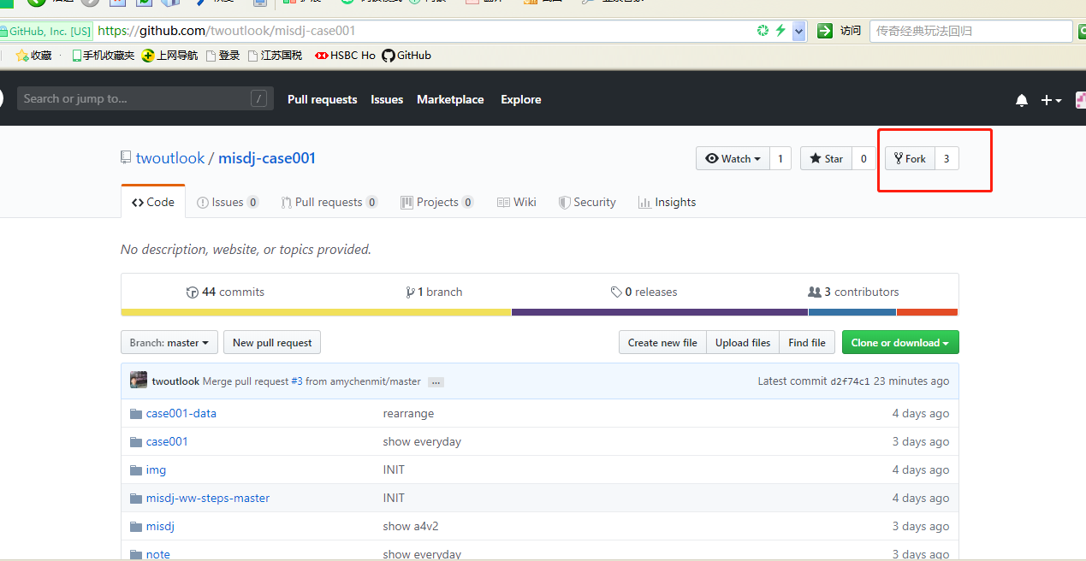

二：进入自己Github下，会发现多一个Repo（名称应该跟总仓库一样，但是因为之前手工建立同名字的Repo，所以这里多了”-1”，名称不影响）

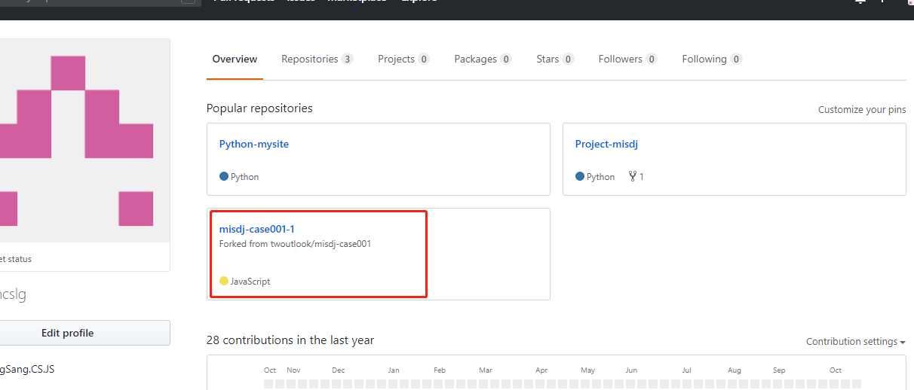

* Clone

三：官网<https://git-scm.com/downloads>  下载git 安装

四：打开Git CMD,进入工作目录进行Clone My Repo

C:\django-team>git clone <https://github.com/Edwincslg/misdj-case001-1>

Cloning into 'misdj-case001-1'...

remote: Enumerating objects: 421, done.

remote: Counting objects: 100% (421/421), done.

remote: Compressing objects: 100% (310/310), done. Receiving objects: 100% (421/421), 6.82 MiB | 1.53 MiB/s, done

Resolving deltas: 100% (144/144), done.

五：C:\django-team>会发现下载下来的misdj-case001-01

需要注意manage.py文件是否为空。如果问空，重新Clone

六：查看本地project clone 的情况

C:\django-team\misdj-case001-1>git remote –v

origin <https://github.com/Edwincslg/misdj-case001-1> (fetch)

origin <https://github.com/Edwincslg/misdj-case001-1> (push)

是clone与Edwincslg下的Repo，不能直接Clone 总仓库的repo

七：安装包

C:\django-team>pip install django-pivot

调试/预览 省略

* **Upload In terminal**

八：sharing 里新建自己MD文档. A.用于记录问题 B.用于Upload前后比对，可以下载Visual Studio Code工具进行编辑MD文档：<https://code.visualstudio.com/Download>

九：上传

**C:\django-team\misdj-case001-1>git add .**

**C:\django-team\misdj-case001-1>git status**

On branch master

Your branch is up to date with 'origin/master'.

Changes to be committed:

(use "git restore --staged <file>..." to unstage)

modified: requirements.txt

new file: sharing/Edwincslg.md

**C:\django-team\misdj-case001-1>git commit -m"FirstCommit"**

*** Please tell me who you are.

Run

git config --global user.email "you@example.com"

git config --global user.name "Your Name"

to set your account's default identity.

Omit --global to set the identity only in this repository.

fatal: unable to auto-detect email address (got 'FIN@DESKTOP-3NL9FK8.(none)')

**C:\django-team\misdj-case001-1>git config --global user.email "xujiancslg@sina.com"**

**C:\django-team\misdj-case001-1>git config --global user.name"Edwincslg"**

**C:\django-team\misdj-case001-1>git commit -m"FirstCommit"**

[master f701fa1] FirstCommit

2 files changed, 11 insertions(+)

create mode 100644 sharing/Edwincslg.md

**C:\django-team\misdj-case001-1>git push -u origin master**

Enumerating objects: 8, done.

Counting objects: 100% (8/8), done.

Delta compression using up to 4 threads

Compressing objects: 100% (5/5), done.

Writing objects: 100% (5/5), 677 bytes | 225.00 KiB/s, done.

Total 5 (delta 3), reused 0 (delta 0)

remote: Resolving deltas: 100% (3/3), completed with 3 local objects.

To https://github.com/Edwincslg/misdj-case001-1

0e6388a..f701fa1 master -> master

Branch 'master' set up to track remote branch 'master' from 'origin'.

* **Pull**

十：打开自己Repo，点击Pull Requests

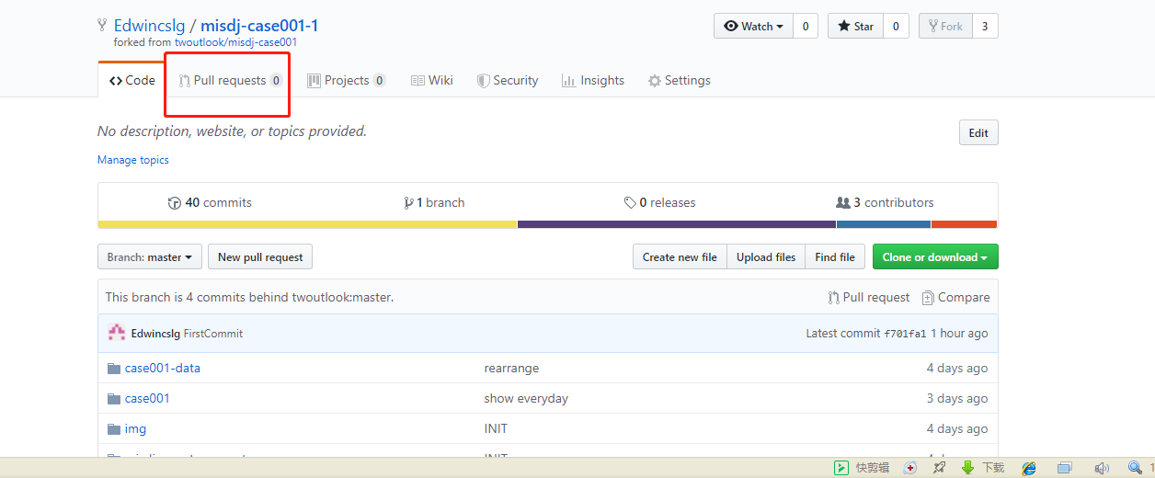

这里可以看到有哪些变动

